Hello! Welcome to my new epic website!!! This is so much fun!!!!
(This is my dad btw)

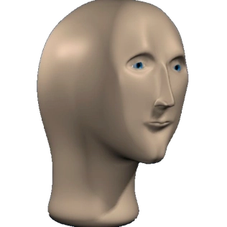

Lol

